Evaluation: ET-OvR
Accuracy: 0.9254108723135271
Precision: 0.9299275722003278
Recall: 0.9254108723135271
F1 Score: 0.9259012674726788
Jaccard Index: 0.863804355674302
Matthews CorrCoef: 0.9048936624617364
Cohen’s Kappa: 0.903610700329635
Specificity: 0.9889327278571971
AUC: 0.9987810124766958
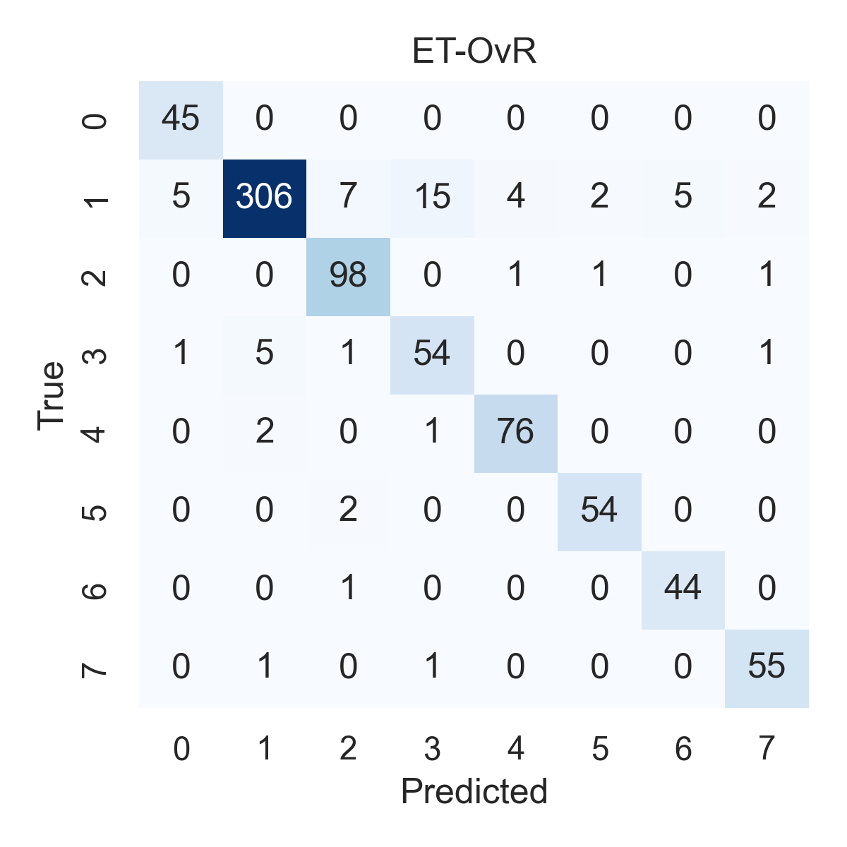

Combined ROC Curves
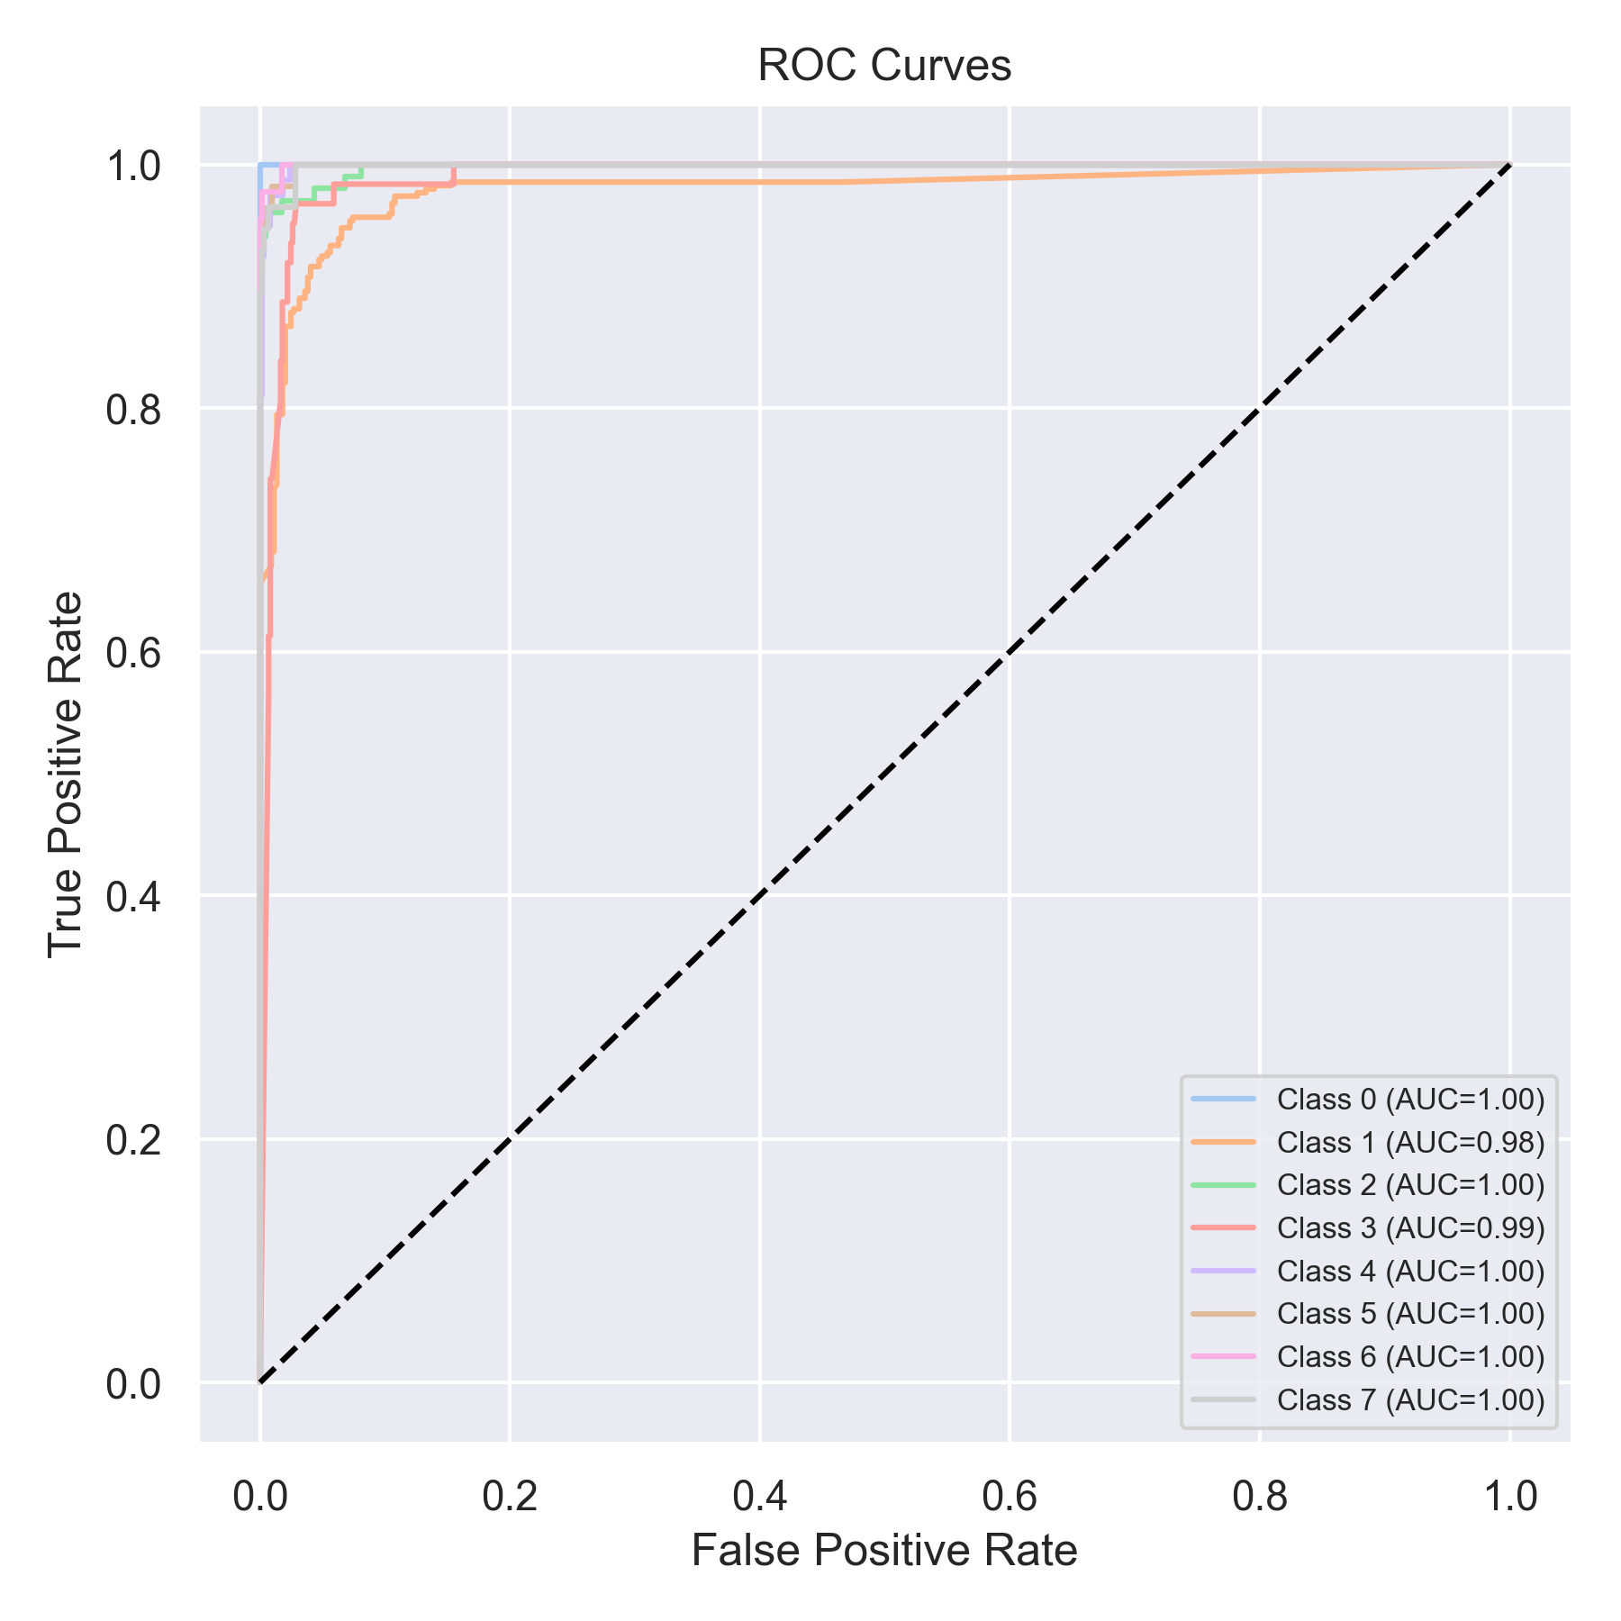

Evaluation: RF-OvR
Accuracy: 0.9140328697850821
Precision: 0.9232995906778525
Recall: 0.9140328697850821
F1 Score: 0.9149610912340753
Jaccard Index: 0.8448046411067245
Matthews CorrCoef: 0.8923248462377381
Cohen’s Kappa: 0.8898071399597645
Specificity: 0.9877536342123002
AUC: 0.9991634399349874
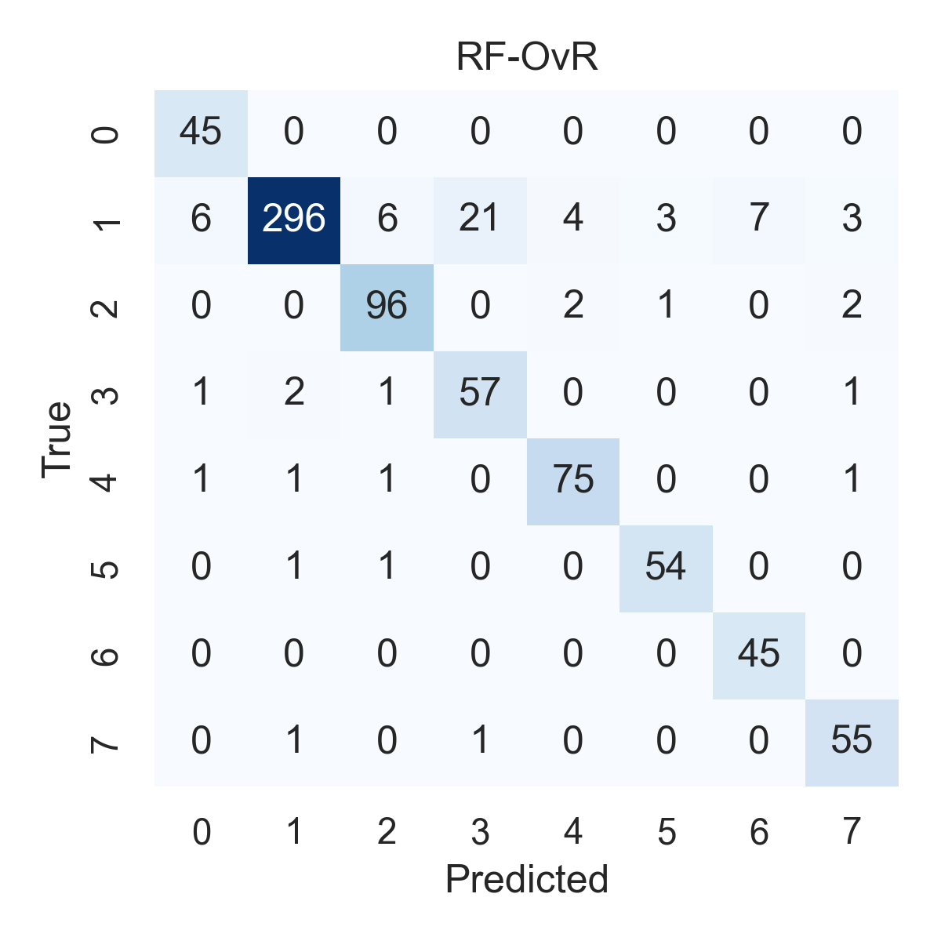

Combined ROC Curves
